**Please find the three logical bugs in the below code snippet marked in green**

**Bug#1:** Successful messages will not meet the condition and can never modify successful messages and can never add a recipient

**Bug#2:** If condition check in canRecieveMessage method should not be satisfied if either of the two conditions are not matching, so it should use ‘&&’(logical AND) operator instead of ‘||’ (logical OR)

**Bug#3:** canRecieveMessage method always returns true even if User and Recipient are not same or if User does not have permission to modify recipients

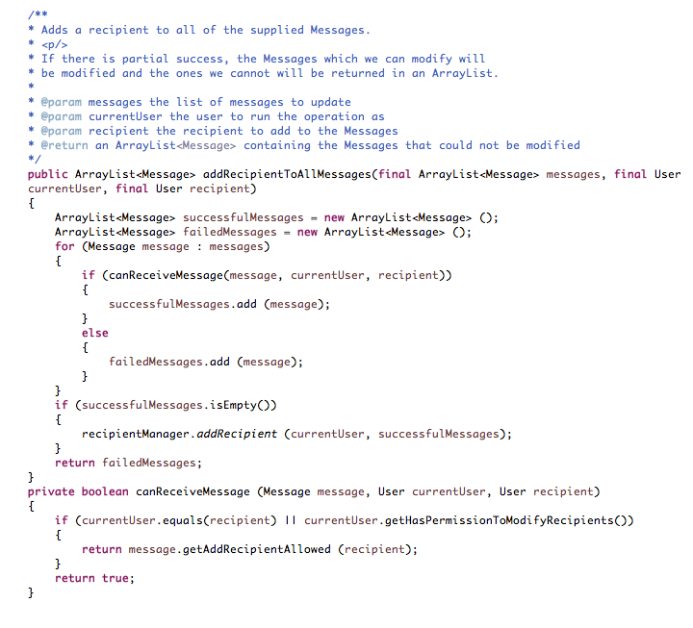

**Below are three automated tests with comments to find bugs in the above code:**

**Scenario-1:** User is same as Recipient and User does not have permissions to modify recipients

**Expected Result**: test case should not allow the user to modify and fail all the messages

The below testcase will find Bug#3(listed above):

@Test

public void TestAddRecipients3() {

User user = new User("MOA");

user.setHasPermissonToModifyRecipients(false);

Message goodMessage = new Message("Test 1");

Message badMessage = new Message("Test 2");

ArrayList<Message> messages = new ArrayList<Message>();

messages.add(goodMessage);

messages.add(badMessage);

goodMessage.setAddRecipientAllowed(user, true);

badMessage.setAddRecipientAllowed(user, true);

CodeExample ce = new CodeExample();

User recipient = new User("MOA");

ArrayList<Message> failedMessages = ce.addRecipientToAllMessages(

messages, user, recipient);

assertEquals(failedMessages.size(), 2);

**Scenario-2:** User is same as Recipient and has permissions to modify recipients and has addrecipient allowed

**Expected Result**: All are successful messages and recipient should be added

The below testcase will find Bug#1(listed above):

@Test

public void TestAddRecipients2() {

User user = new User("MOA");

user.setHasPermissonToModifyRecipients(true);

Message Message1 = new Message("Test 1");

Message Message2 = new Message("Test 2");

goodMessage.setAddRecipientAllowed(user, true);

badMessage.setAddRecipientAllowed(user, true);

ArrayList<Message> messages = new ArrayList<Message>();

messages.add(Message1);

messages.add(Message2);

CodeExample ce = new CodeExample();

User recipient = new User("MOA");

ArrayList<Message> successfulMessages = ce.addRecipientToAllMessages(

messages, user, recipient);

asserttrue(successfulMessages.get(1).recipient.equals("MOA"));

}

**Scenario-3:** User and Recipient are different and User does not have permission to modify recipients

**Expected Result:** It should return all the messages as failed messages

The below testcase will find Bug#2(listed above):

@Test

public void TestAddRecipients1() {

User user = new User("MOA");

user.setHasPermissonToModifyRecipients(false);

Message goodMessage = new Message("Test 1");

Message badMessage = new Message("Test 2");

goodMessage.setAddRecipientAllowed(user, true);

badMessage.setAddRecipientAllowed(user, true);

ArrayList<Message> messages = new ArrayList<Message>();

messages.add(goodMessage);

messages.add(badMessage);

CodeExample ce = new CodeExample();

User recipient = new User("admin");

ArrayList<Message> failedMessages = ce.addRecipientToAllMessages(

messages, user, recipient);

assertEquals(failedMessages.size(), 2);

}